

Darshan University

A Project Report on

**“Online course management system”**

Under the subject

**Software Engineering (2101CS503)**

B. Tech, Semester – VI

Computer Science & Engineering Department

|  |  |
| --- | --- |
| Submitted By | |
| Student Name:Parmar Vivek | Enrollment No.:24010101672 |
| Academic Year  (2023-2024) | |
| Internal Guide  Prof. XYZ  Darshan University | Dean-DIET  Dr. Gopi Sanghani  Darshan University |

|  |  |
| --- | --- |
|  | **Computer Science & Engineering Department**  **Darshan University** |

**DECLARATION**

We hereby declare that the SRS, submitted along with the **Software Engineering** **(2101CS503)** for entitled **“Online course management system”** submitted in partial fulfilment for the Semester-5 of **Bachelor Technology (B. Tech)** in **Computer Science and Engineering (CSE)** Departmentto Darshan University, Rajkot, is a record of the work carried out at **Darshan University, Rajkot** under the supervision of (**Guide name)** and that no part of any of report has been directly copied from any students’ reports, without providing due reference.

(Student name)

Student’s Signature

Date: __________

|  |  |
| --- | --- |
|  | **Computer Science & Engineering Department**  **Darshan University** |

**CERTIFICATE**

This is to certify that the SRS on **“Project Title” has** been satisfactorily prepared by **Student name** (**Enrollment**) under my guidance in the fulfillment of the course **Software Engineering (2101CS503)** work during the academic year 2023-2024.

|  |  |  |
| --- | --- | --- |
| Internal Guide  Prof., Guide Name  Darshan University |  | Dean-DIET  Dr. Gopi Sanghani  Darshan University |

**Acknowledgement**

I wish to express my sincere gratitude to my project guide Prof. **Guide name** and all the faculty members for helping me through my project by giving me the necessary suggestions and advices along with their valuable co- ordination in completing this work.

I also thank my parents, friends and all the members of the family for their precious support and encouragement which they had provided in completion of my work. In addition to that, I would also like to mention the Darshan University personals who gave me the permission to use and experience the valuable resources required for the project from the University premises.

Thus, in conclusion to the above said, I once again thank the faculties and members of **Darshan University** for their valuable support in completion of the project.

Thanking You

**Student Name**

**ABSTRACT**

The Online Course Management System (OCMS) is a software platform designed to simplify and enhance the management of educational courses for students, teachers, and administrators. It provides a centralized interface to manage various aspects of online learning, including course registration, attendance, assignment submissions, and performance tracking.

This system is particularly useful for educational institutions that want to deliver courses online or manage hybrid learning models. Students can enroll in courses, access study materials, and communicate with instructors seamlessly. Teachers can organize their course materials, upload resources, assign grades, and monitor student progress. Administrators benefit from tools to manage the entire system efficiently, including user accounts, course schedules, and analytics.

**Table of Contents**

List of Figures I

List of Tables II

1 Introduction 1

1.1 Product perspective 1

1.2 Product features 1

1.2.1 There are three different users who will be using this product: 1

1.2.2 The features that are required for the Librarian are: 1

1.2.3 The features that are required for the Member are: 1

1.3 Functional Requirement 1

1.3.1 Librarian 1

1.3.2 Member 2

1.4 Non-Functional Requirement 2

1.4.1 Usability: 2

1.4.2 Accuracy: 2

1.4.3 Availability: 2

1.4.4 Maintainability: 2

2 Design and Implementation Constraints 3

2.1 Use case diagram 3

2.2 Activity diagram and Swimlane diagram 4

2.3 Sequence diagram 5

2.4 State diagram 6

2.5 Class diagram 7

2.6 Data flow diagram 8

2.6.1 Context diagram (level-0) 8

2.6.2 DFD Level-1 8

2.6.3 DFD Level-2 9

3 External interface requirement (Screens) 10

3.1 Screen-1: Registration Form 10

3.2 Screen-2: Login Form 11

3.3 Screen-3: Add borrower book 12

4 Database design 13

4.1 List of Tables 13

5 Stories and Scenario 14

5.1 Story-1: Add New Book in Library Catalogue 14

5.1.1 Scenario# S1.1 14

5.1.2 Scenario# S1.2 14

5.1.3 Scenario# S1.3 14

5.2 Story-2: Search Book 15

5.3 Story-3: Manage due date for borrowed book 15

5.4 Story-4: Renew book 15

5.5 Story-5: Generate a report on book usage and availability 15

6 Test cases 16

7 References 20

# List of Figures

Figure 2.1‑1 Use case diagram for library management system 3

Figure 2.2‑1 Activity diagram for Book Issue 4

Figure 2.2‑2 Swimlane diagram for Book Issue 4

Figure 2.3‑1 Sequence diagram for Book Issue 5

Figure 2.4‑1 State diagram of Book 6

Figure 2.4‑2 State diagram for Librarian 6

Figure 2.5‑1 Class diagram for Library management system 7

Figure 2.6‑1 Context diagram for Library management system 8

Figure 2.6‑2 DFD level-1 for Library management system 8

Figure 2.6‑3 DFD level-2 for Issue book 9

Figure 3.1‑1 Screen-1: Registration Form 10

Figure 3.2‑1 Screen-2: Login Form 11

Figure 3.3‑1 Screen-3: Add borrower book 12

# List of Tables

Table 3.1‑1 Screen element of Registration form 10

Table 3.2‑1 Screen element of Login form 11

Table 3.3‑1 Screen element of Add borrower book 12

Table 4.1‑1 Table: Book 13

Table 4.1‑2 Table: Borrower 13

Table 4.1‑3 Table: Staff 13

Table 4.1‑4 Table: Student 13

# Introduction

## Product perspective

This project is basically updating the manual library system into an internet-based application so that the users can know the details of their account, availability of books etc. It is a multi-user version and can take care of all the fundamental functions of a Library like Cataloguing, Circulation, Accessioning and Housekeeping. It can satisfactorily cater to all the basic functions of a small library.

## Product features

### There are three different users who will be using this product:

* Librarian who will be acting as the administrator.
* Member who will be accessing the library.
* Guest who will request for membership.

### The features that are required for the Librarian are:

* Control the movement of books and other material and avoid losing the same.
* Search if you have a specific book in your collection based on the title, author etc.
* Print the spine labels for the book.
* Find what a specific person has borrowed from you. It offers the following modules Cataloguing, Circulation, and Queries.
* Can issue a book to the student.
* Can view the list of books available in each category.
* Can take the book returned from students.
* Add books and their information of the books to the database.
* Edit the information of the existing books.
* Can check the report of the issued Books.
* Can access all the accounts of the students.

### The features that are required for the Member are:

* Can view the different categories of books available in the library.
* Can view the List of books available in each category.
* Can own an account in the library.
* Can view the books issued to him.
* Can put a request for a new book.

## Functional Requirement

### Admin

* Add Faculty: Admin can add faculty after take interview of Faculty
* Delete Faculty: Admin can remove the Faculty if faculty are not learning well
* Faculty Requests: Admin can approve or reject the person as faculty after the interview
* Faculty Details: Admin can see history and details of faculty

### faculty

* Authentication: Faculty must be authenticated before accessing system
* Add course: Used to add course
* Edit/delete: faculty can edit/delete course.
* Add/delete videos: faculty can add/delete videoes according course
* Add/delete material: faculty can add/delete materials according course

### Student

* Authentication: student must be authenticated before accessing system
* Buy course: student can buy course which he/she want
* Search course : student can search course according course name or faculty name
* Contact with faculty: student can have also contact of faculty according course
* See course material: student can also see course materials.
* Course wishlist: student can tick course as wishlist.

## Non-Functional Requirement

### Usability:

* The UI should be simple enough for everyone to understand and get the relevant information without any special training. Different languages can be provided based on the requirements.

### Accuracy:

* The data stored about the books and the fines calculated should be correct, consistent, and reliable.

### Availability:

* The System should be available for the duration when the library operates and must be recovered within an hour or less if it fails. The system should respond to the requests within two seconds or less.

### Maintainability:

* The software should be easily maintainable and adding new features and making changes to the software must be as simple as possible. In addition to this, the software must also be portable.

# Design and Implementation Constraints

## Use case diagram

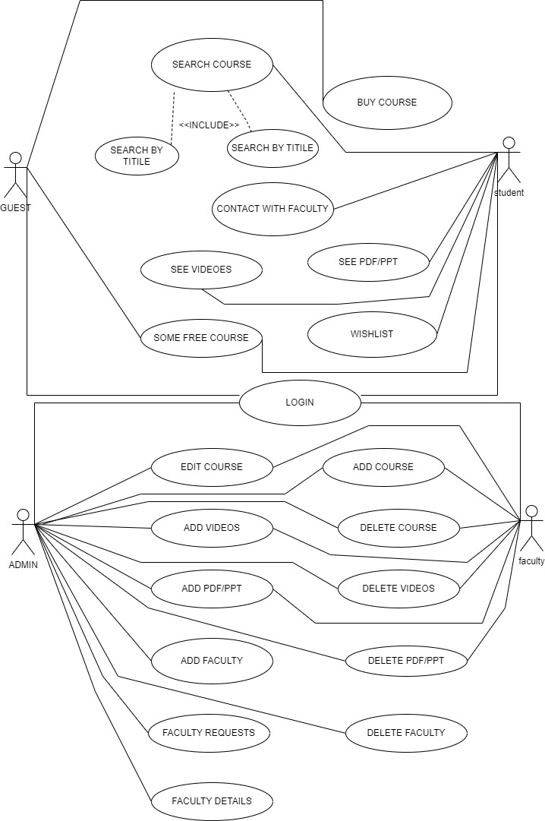

Figure 2.1‑1 Use case diagram for library management system

## Activity diagram and Swimlane diagram

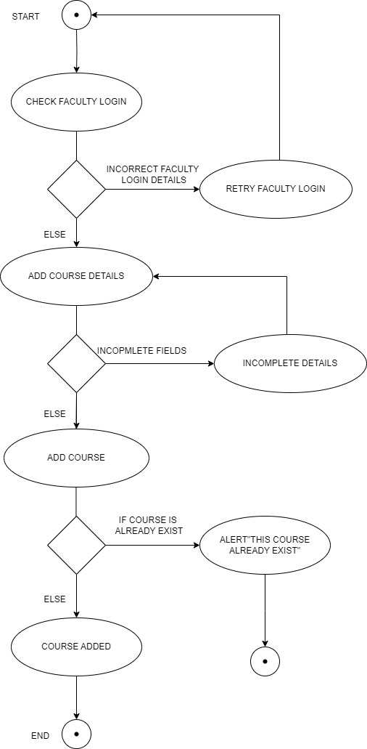

Figure 2.2‑1-1 Activity diagram for online course management system

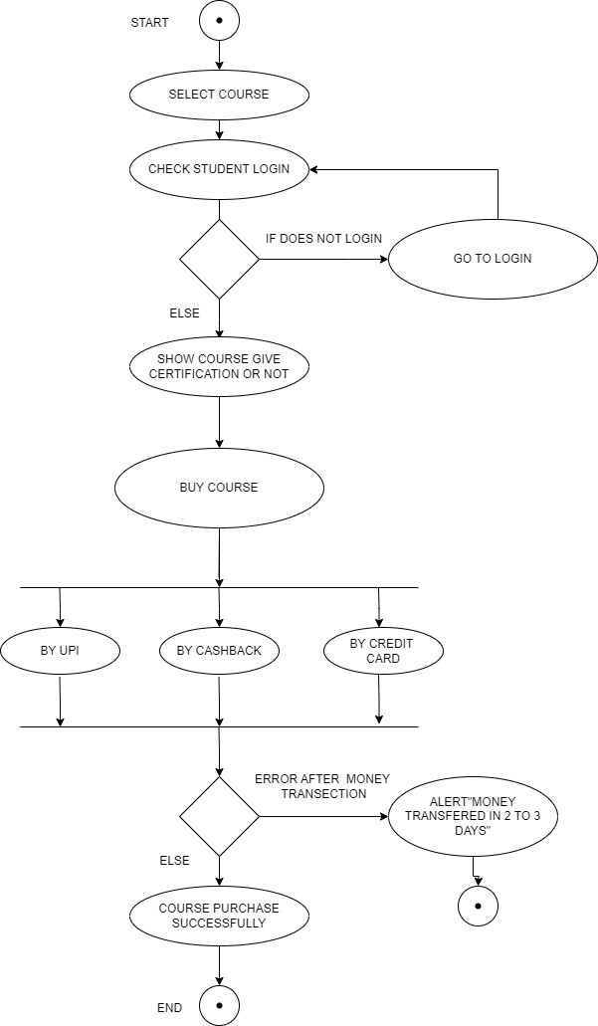

Figure 2.2‑1-2 Activity diagram for online course management system

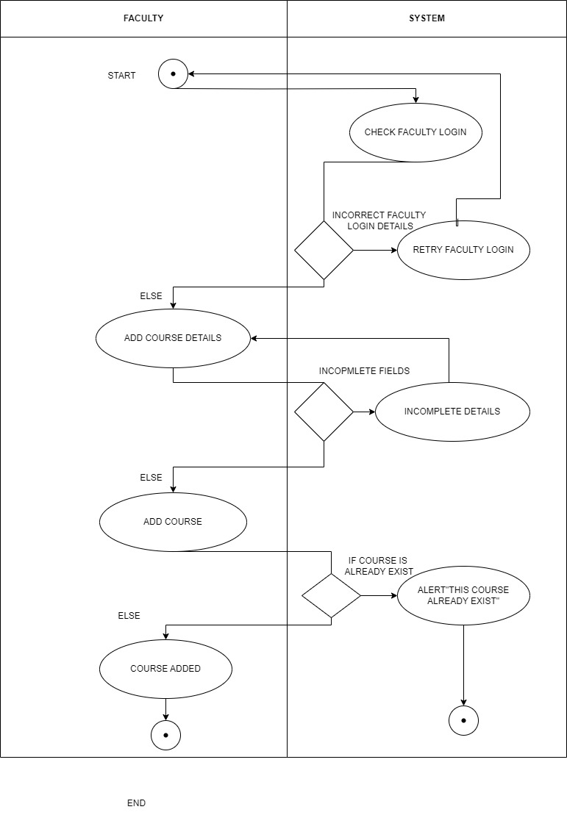

Figure 2.2‑2-1 Swimlane diagram for online course management system

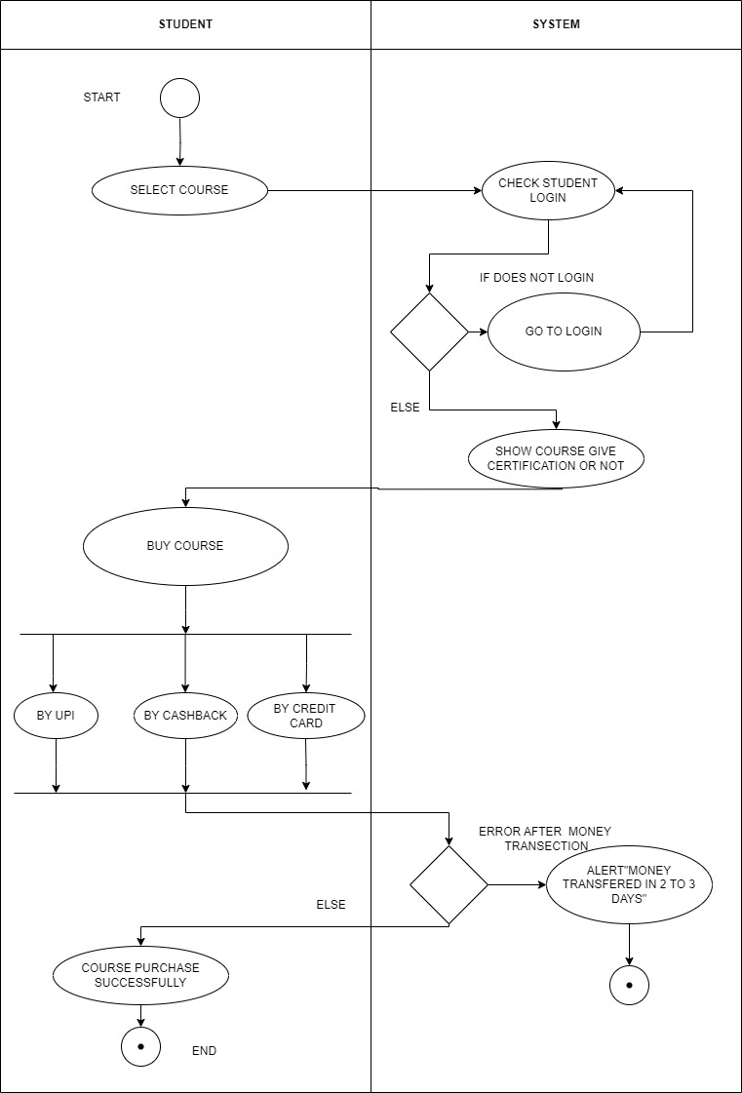

Figure 2.2‑2-1 Swimlane diagram for online course management system